Sex Chromosomes (7)

  - Autosomes and sex chromosomes.
  - Mechanism of Sex determination.
  - Sex chromosomes in Drosophila.
  - Sex chromosomes in Man.
  - Balance concept of Sex determination in Drosophilla - Bridge’s Experiment.
  - Sex-linked inheritance in man –
a) Colour blindness
b) Haemophilia.
c) Holandric genes.

4.1. Autosomes and sex chromosomes:
1. Autosomes: The chromosomes which have no relation with the sex and contain the genes which determine the somatic characters of the individuals are known as Autosomes (A).
2. Sex chromosomes: The chromosomes which are responsible for the determination of sex are known as sex chromosome, e.g. X and Y chromosomes.
An allosome is a sex chromosome that differs from an ordinary autosome in form, size, and behavior. The human sex chromosomes are a typical pair of allosomes. These chromosomes determine the sex of an individual when reproducing. Allosomes are also referred to as sex chromosomes or idiosomes. Autosomes differ from allosomes because autosomes appear in pairs whose members have the same form but differ from other pairs in a diploid cell, whereas members of an allosome pair may differ from one another and thereby determine sex.

4.2 Mechanism of Sex determination:
In dioecious diploidic organisms following two systems of sex chromosomal determination of sex have been recognized.
- Heterogametic males.
- Heterogametic females.
- Heterogametic Males:
In this type of sex chromosomal determination of sex, the female sex has two X
chromosomes, while the male sex has only one X chromosome. Because, male lacks a X chromosome, therefore, during gametogenesis produces two types of gametes, 50% gametes carry the X chromosomes, while the rest 50% gametes lack in X chromosome. Such a sex which produces two different types of gametes in terms of sex chromosomes, called heterogametic sex. The female sex, produces similar types of gametes, is called, homogametic sex. The heterogametic males may be of following two types.
- XX-XO type: In certain insects specially those of the orders Hemiptera (true bugs) and Orthoptera (grasshoppers and cockroaches), the female having two X chromosomes (hence referred to as XX) and are thus homogametic, while the male having only one X chromosome (hence referred to as XO). The presence of an unpaired X chromosomes determine the masculine sex. The male being heterogametic sex produces two types of sperms: half with X chromosomes and half without X chromosome. The sex of the offspring depends upon the sperm that fertilizes the egg (each of which carries a single X chromosome) as shown in fig.

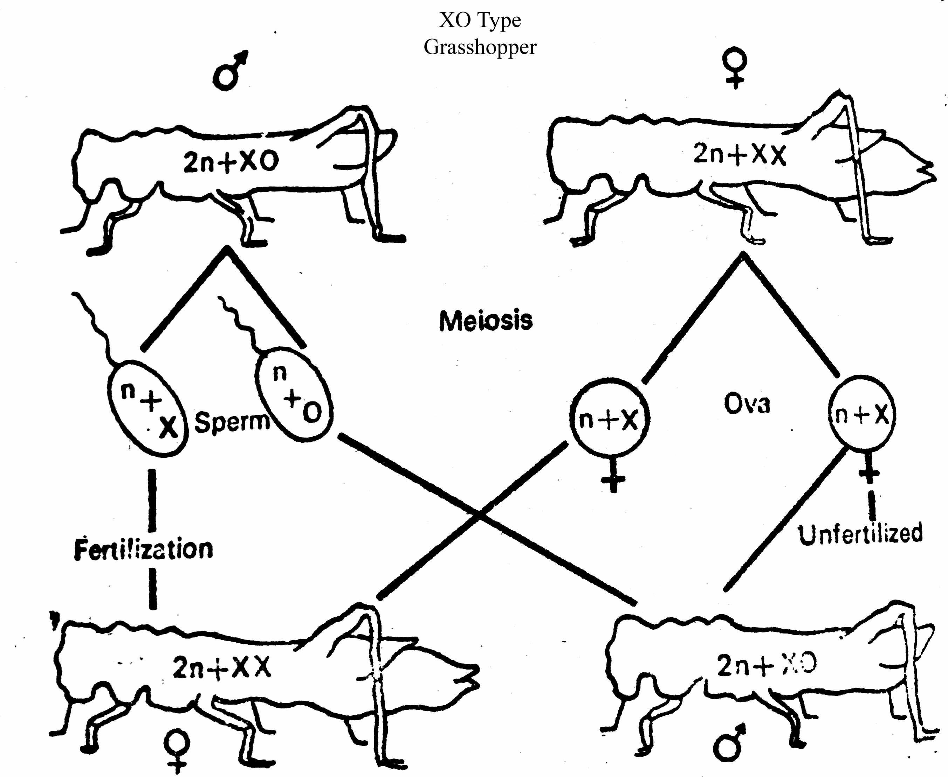

- XX-XY type: In main, other mammals, certain insects including Drosophila and Lygaeus turcicus and in certain angiospermic plants such Melandrium, the female possesses two homomorphic X chromosomes in their body cells (hence referred to as XX) and they being homogametic, produce one kind of eggs, each with one X chromosome. The males of these organisms posses one X chromosome and one Y chromosome (hence referred to as XY). The males having two heteromorphic sex chromosomes and half with Y chromosome. The sex of embryo depends on the kind of sperm. An egg fertilized by a X-bearing sperm produces a female, but, if fertilized by a Y-bearing sperm, a male is produced.

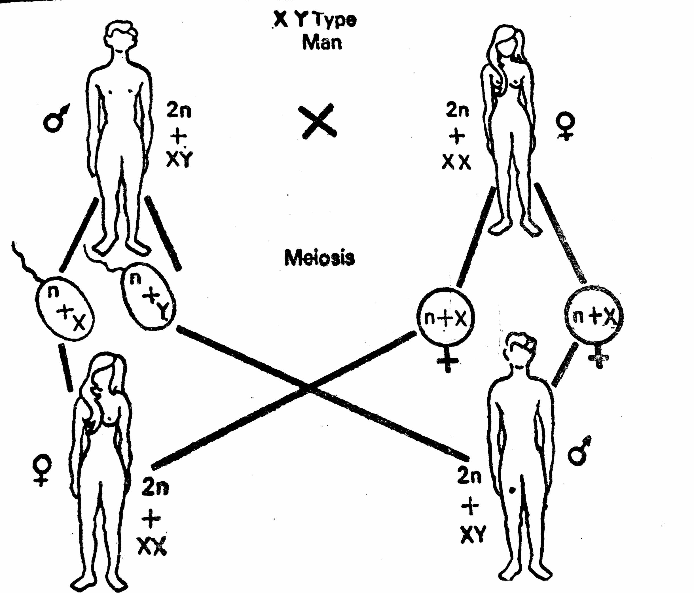

- Heterogametic Females:
In this type of sex chromosomal determination of sex, the male sex possesses two homomorphic X chromosomes, therefore, is homogametic and produces single type of gametes; each carries a single X chromosome. The female sex either consists, or single X chromosome or one X chromosome and one Y chromosome. The female sex is, thus, heterogametic and produces two types of eggs, half with a X chromosome and half without a X chromosome (with or without a Y chromosome). To avoid confusion with that of XX-XO and XX-XY type of sex determining mechanisms, instead of the X and Y alphabets, Z and W alphabets are generally used respectively. This kind of sex determination mechanism is called Abraxas mechanism of sex determination.
The heterogametic females may be of following two types:

i. ZO-ZZ system: This system of sex determination is found in certain moths, butterflies and domestic chickens. In this case, the female possesses single Z chromosome in its body cells (hence, is referred to as ZO) and is heterogametic, producing two kinds of eggs, half with a Z chromosomes and half without any Z chromosome. The male possesses two Z chromosomes (hence referred to as ZZ) and is homogametic, producing single type of sperms, each of which carries a single Z chromosome. The sex of the offspring depends on the kind of egg as shown below.

Parent : Female X Male
2A+ZO 2A+ZZ

Gametes : (A+Z)(A+O) (A+Z)(A+Z)

Ova Sperms

F1 : 2A+ZZ 2A+ZO
Male Female

- ZW-ZZ system: This system of sex determination occurs in certain insects and vertebrates such as fishes, reptiles and birds. Here the female sex has one Z chromosome and one W chromosome. It is heterogametic and produces two types of ova 50% ova carry the Z chromosomes, while rest 50% ova carry W chromosomes. The male sex has two homomorphic Z chromosomes and is homogametic producing single type of sperms, each carries a Z chromosome. The sex of the offspring depends on the kind of egg, the Z bearing eggs produces males but the W bearing eggs produce females.

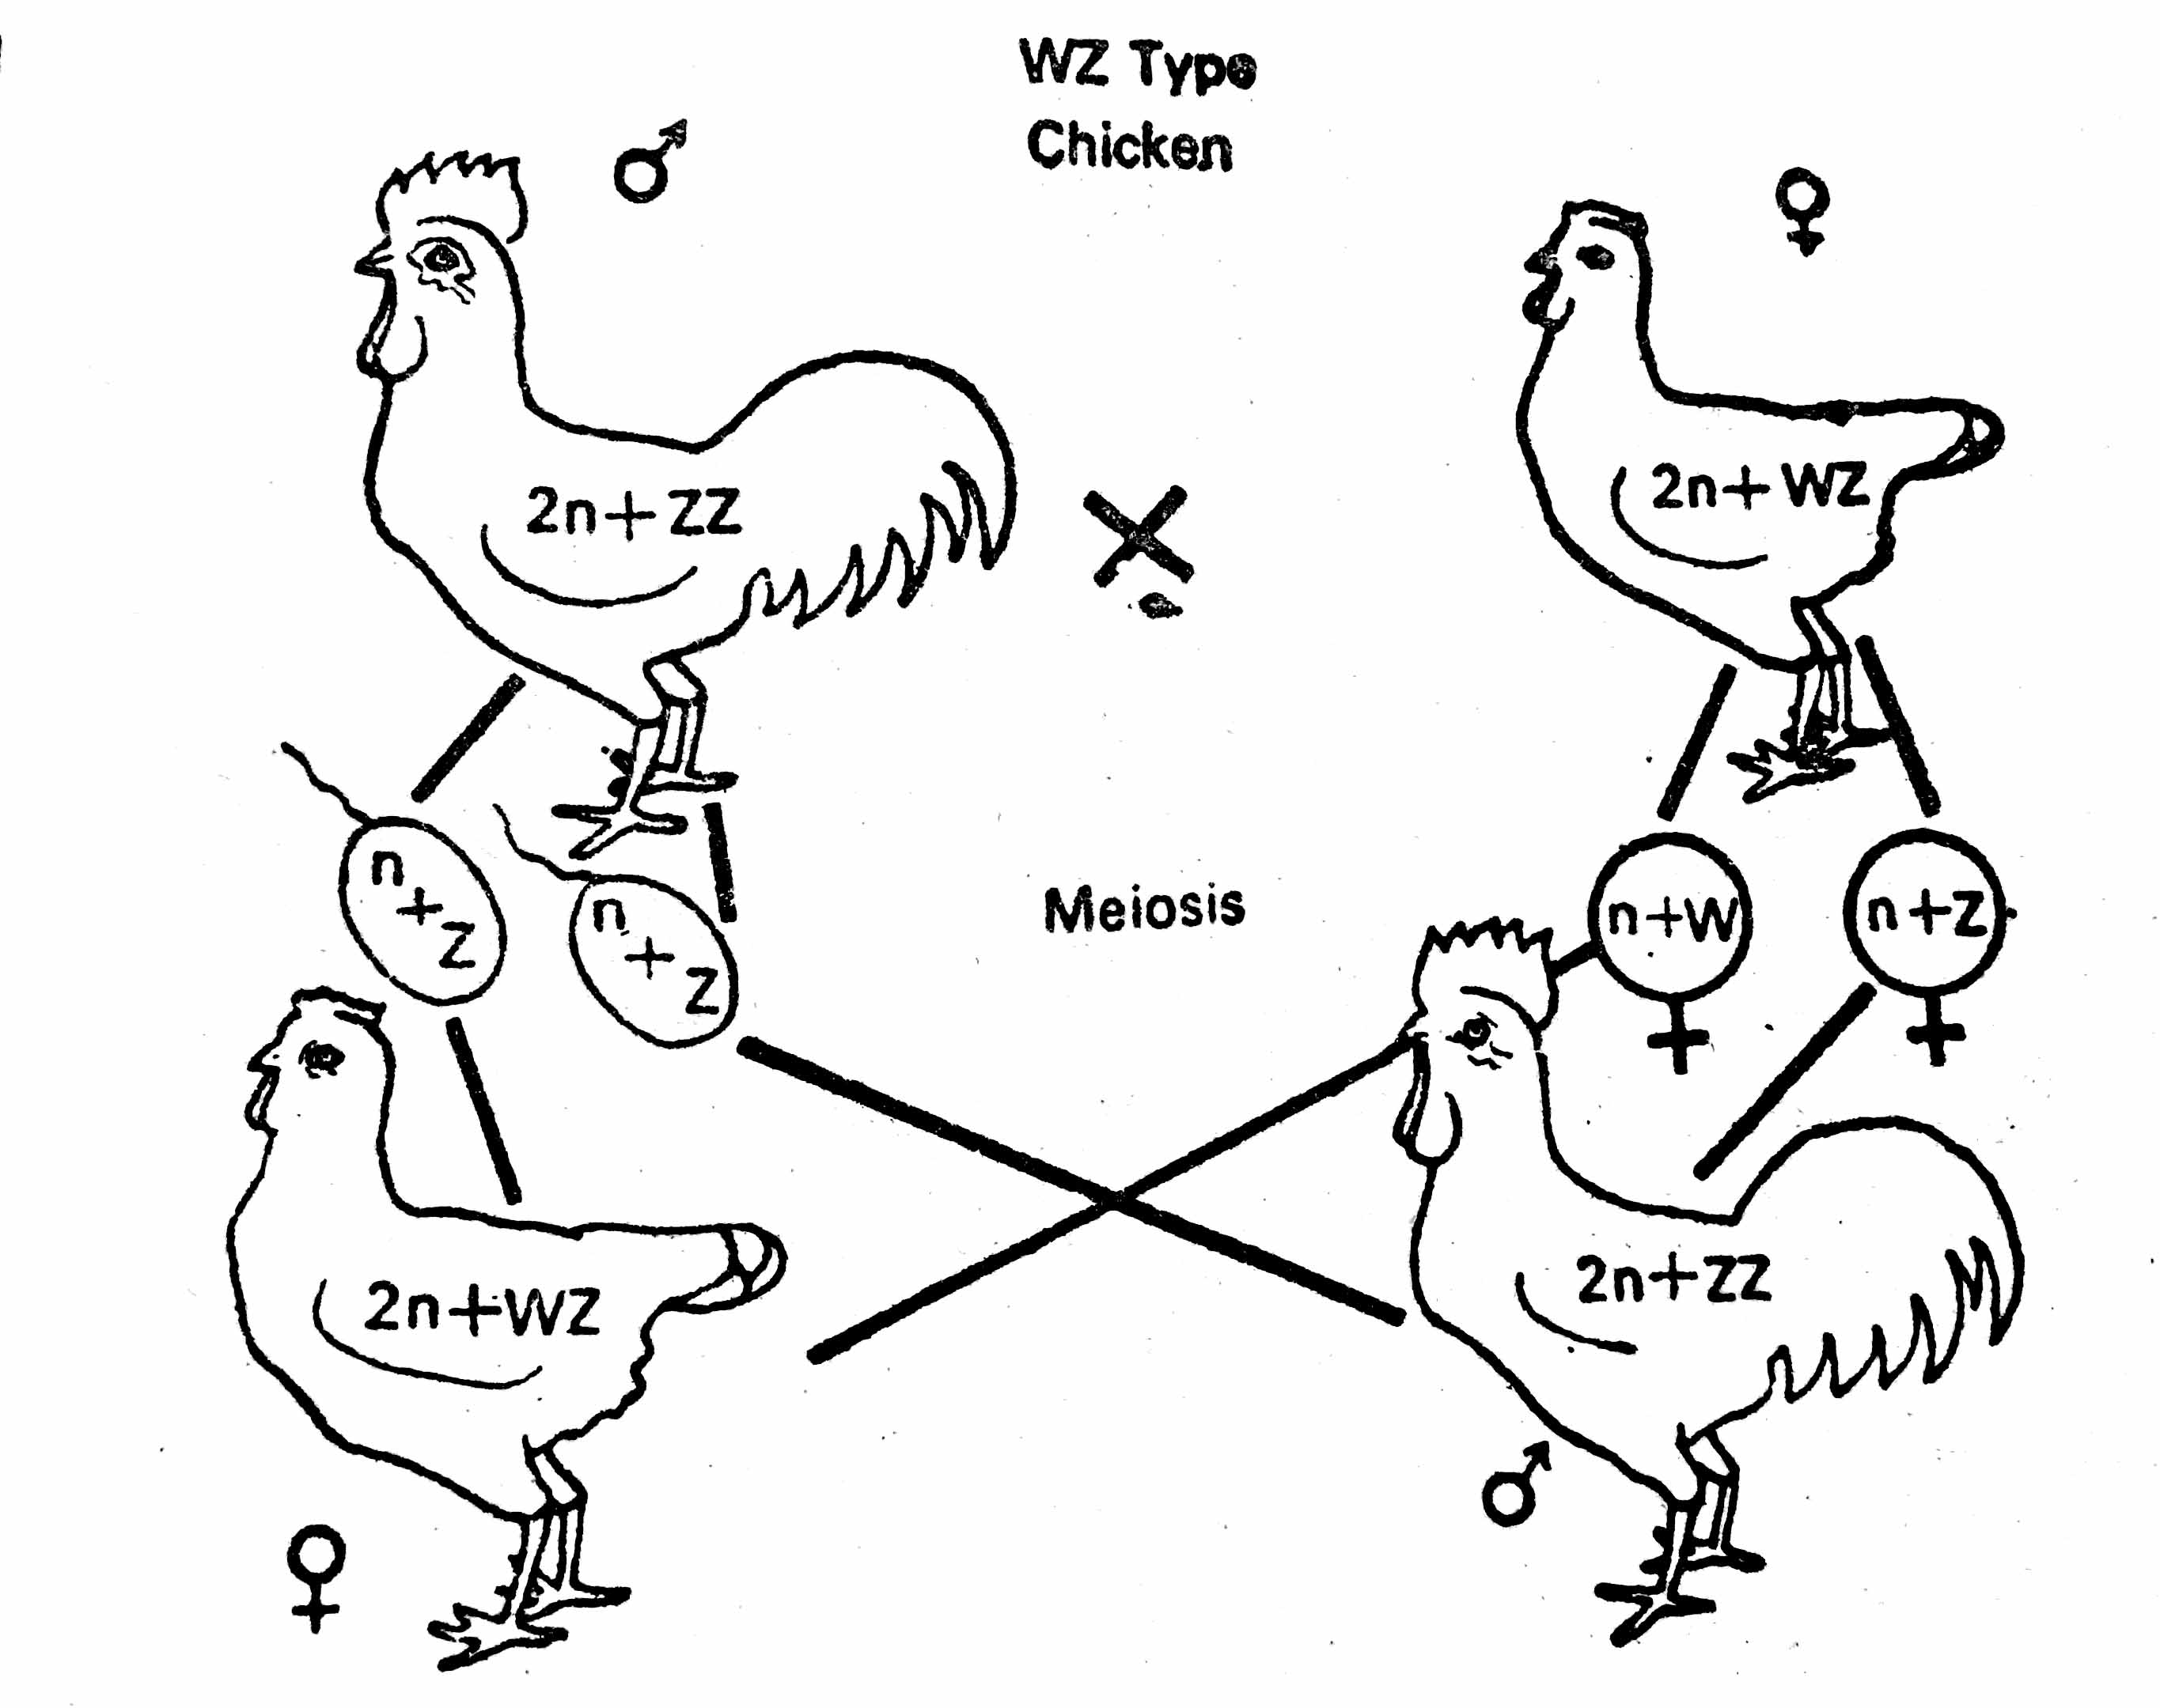

  - Sex chromosomes in Drosophila.
In a Drosophila fly, there are only three autosomes, called autosomes 2, 3 and 4. Autosome 4 is really very small in size. In a diploid cell, there are three pairs of autosomes, or six non-sex chromosomes, and a pair of sex chromosomes. These two sex chromosomes could be either an X or a Y. However, it is seen that it can be more complicated than this, leading to more sexes in flies than just female or male.

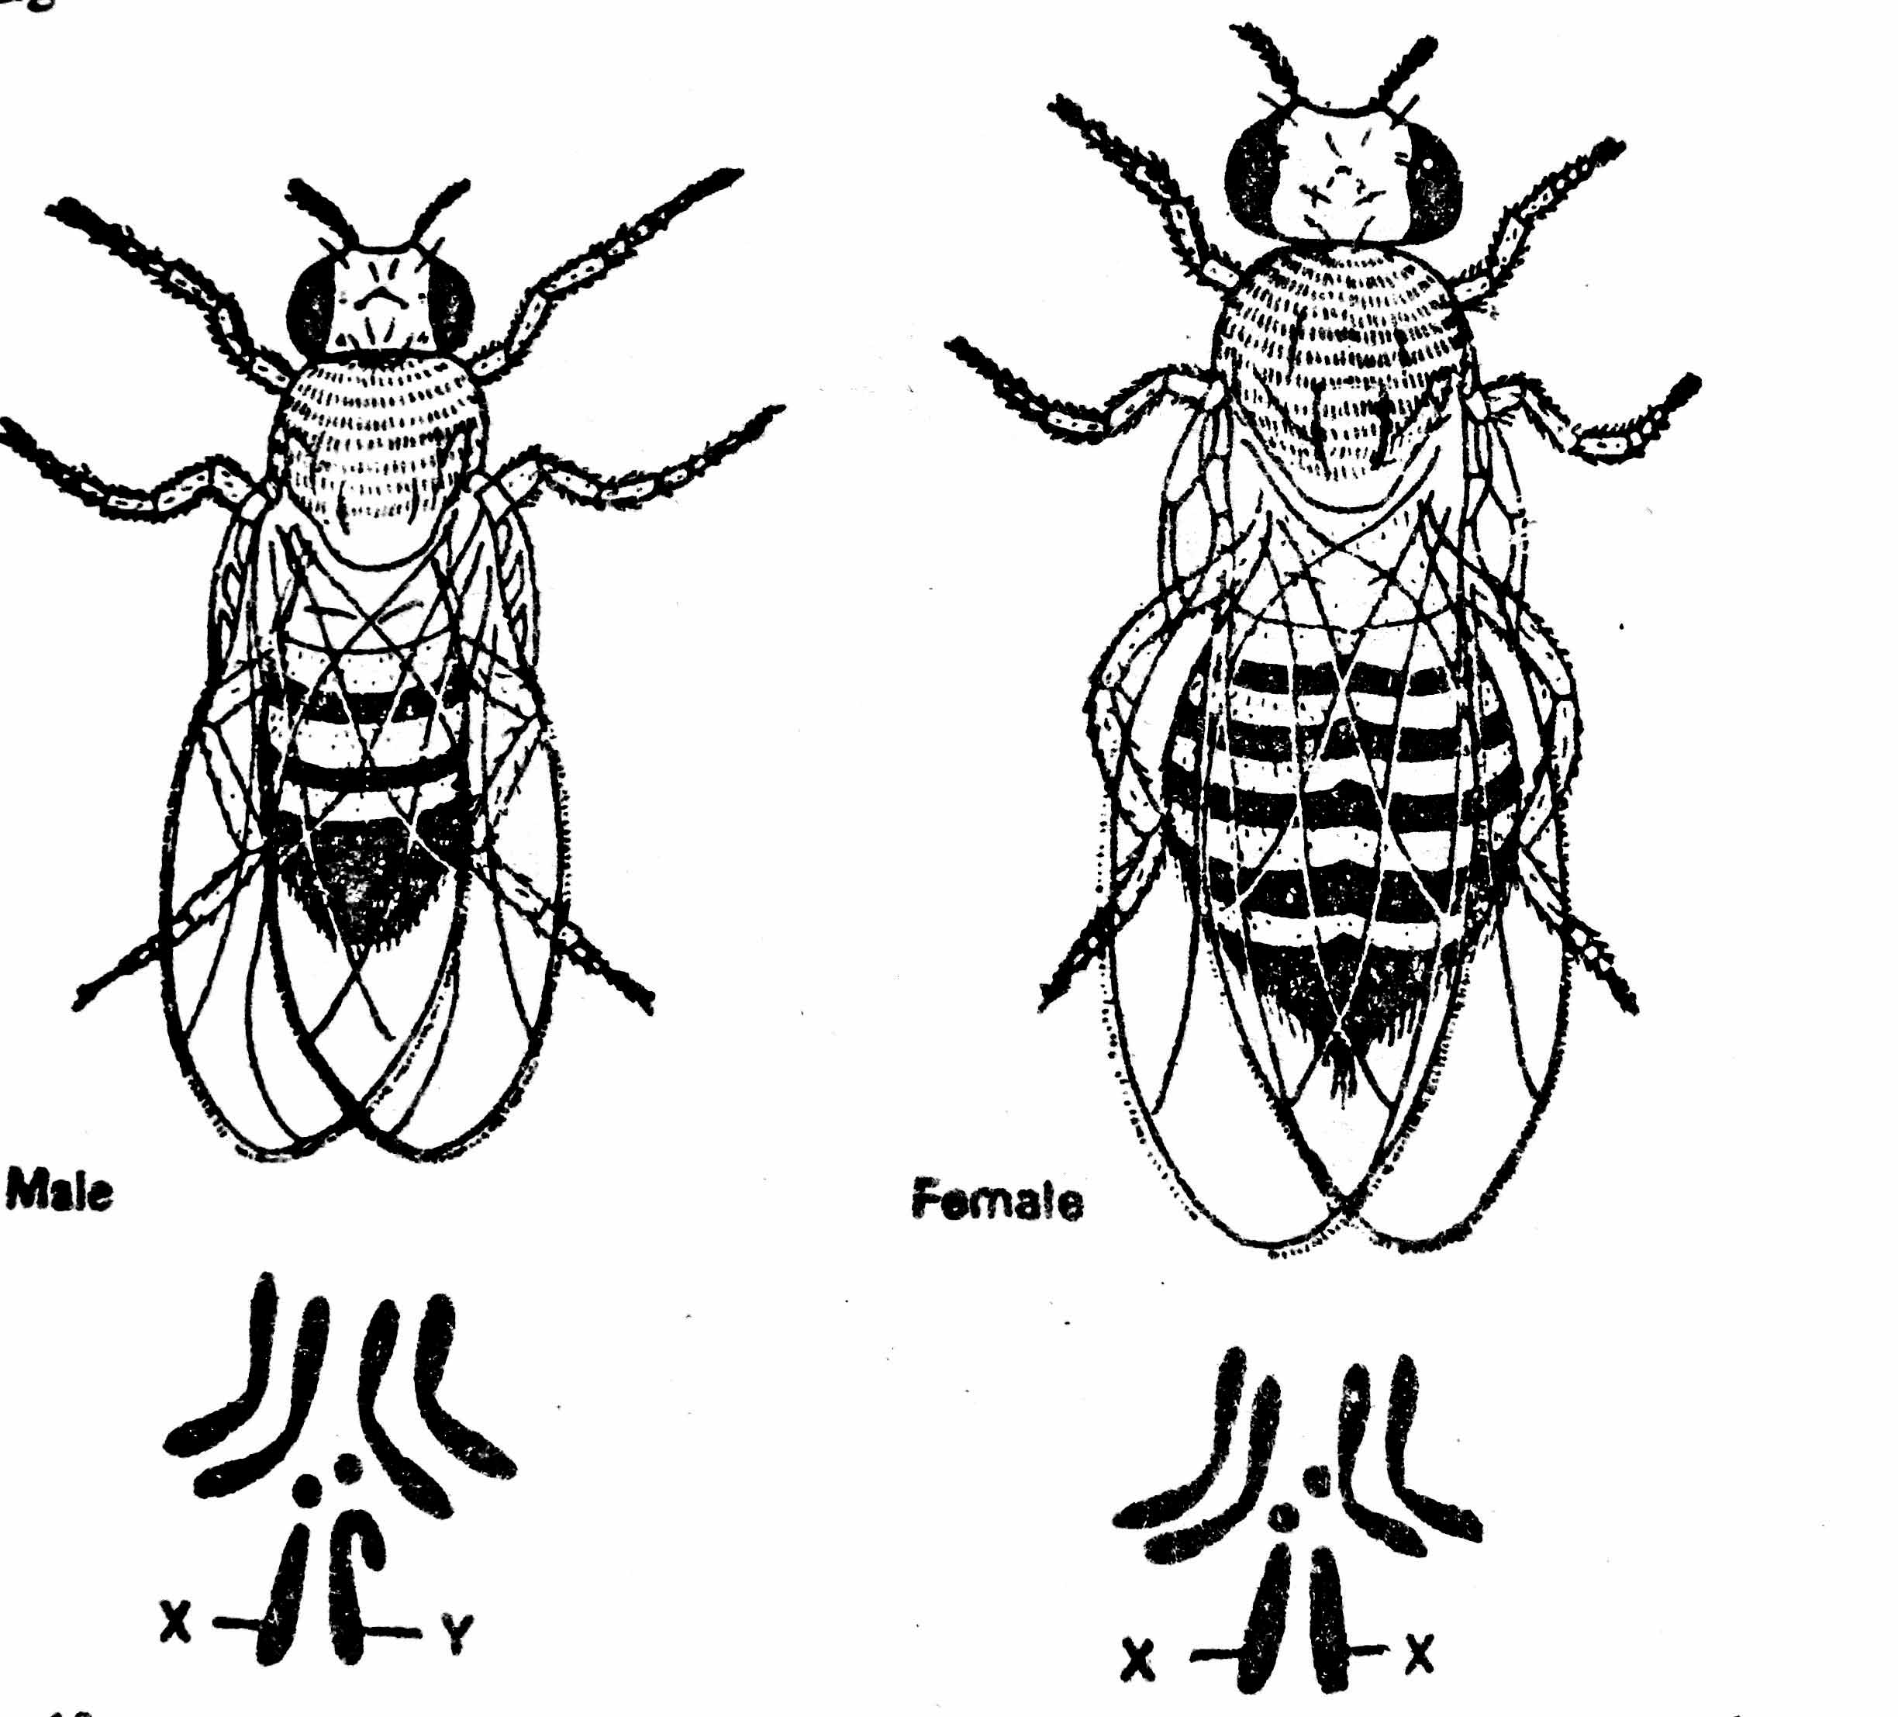

4.4 Sex chromosomes in Man.
There are 46 total chromosomes in a human diploid cell, with two of these 46 chromosomes, or one pair, being the sex chromosomes (either an X or a Y). The other 44 chromosomes, in 22 pairs, are all known as autosomes. It's not so hard to determine sex in humans. In fact, you probably have this one down pat. Usually, it's as simple as the fact that an XX genotype is female, while an XY genotype is genetically male. The autosomes don't influence human sex.

Balance concept of Sex determination in Drosophila:
By studying sex chromosomal mechanism of sex determination, it may appear at first glance that some genes carried by the sex chromosomes (X and Y) were entirely responsible for sex. But this is not the case. Extensive experimentation of different workers on different organisms have revealed the fact that most organisms generally have inherent potentialities for both sexes and each individual is found to be more or less intermediate between male and female sexes (hence may be referred to as intersex). There seems to exist a delicate balance of an individual and mechanism like the XY, ordinarily serve to trip the balance in one direction or another. Such genic balance mechanism of determination of sex was first of all studied in Drosophila by C. B. Bridges in 1921.

Sex Determination in Drosophila:
According to the genic balance theory of Bridges, in Drosophila melanogaster sex is determined by the ratio of the X-chromosomes and the autosomes, the Y-chromosome not being of any importance in this respect. It does however, contain male-fertility factors, XO flies are male, but sterile. In this fly the sex is determined polygenically. Unlike humans, the Y chromosome does not confer maleness; rather, it encodes genes necessary for making sperm. Sex is instead determined by the ratio of autosomes to X chromosomes. Furthermore, each cell "decides" whether to be male or female independently of the rest of the organism resulting in the occasional occurrence of gynandromorphs (contains both male and female characteristics)

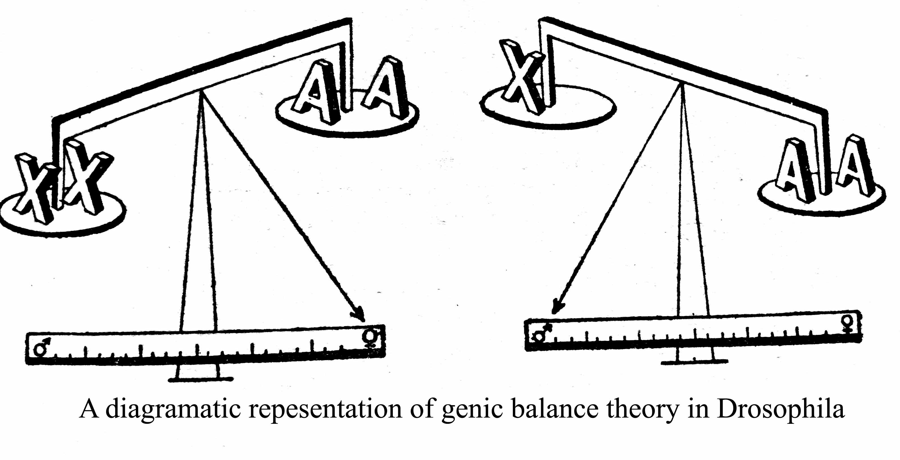

X Chromosomes | Autosomes | Ratio of X:A | Sex
XXXX | AAAA | 1 | Normal Female
XXX | AAA | 1 | Normal Female
XXY | AA | 1 | Normal Female
XXYY | AA | 1 | Normal Female
XX | AA | 1 | Normal Female
X | AA | 0.50 | Normal Male (sterile)
XXX | AA | 1.50 | Metafemale
XXXX | AAA | 1.33 | Metafemale
XX | AAA | 0.66 | Intersex
X | AAA | 0.33 | Metamale

4.6. Sex-linked inheritance in man –
XX-XY chromosomes are primarily concerned with the determination of sex. These do carry some genes for other body characters. Such body characters whose genes are located on the sex chromosomes and follow sex during inheritance are known as ‘sex -linked characters. The genes governing the sex linked characters are called ‘sex- linked genes.’ The mode of inheritance by the sex-linked genes is described as sex-linked inheritance.
The genes present on the X-chromosome are called sex-linked genes or X-linked genes and the genes occur on Y-chromosome are known as Holandric genes. Holandric genes are present only in males. Certain characters are not sex-linked but are limited to one sex. These are described as sex-limited characters and sex-influenced characters. One of the earliest known instance of sex-linked character is the Bleeder’s disease-Hemophilia’ found only in males in the royal family of Spain. In 1910, Thomas Hunt Morgan introduced the concept of sex-linked inheritance while working on Drosophila melanogaster.
Approximately twenty characters of man exhibit sex-linked inheritance. The most popular examples of sex-linked inheritance in Man are
- Red-green colour blindness and
- Hemophilia.
Morgan’s experiment to explain sex linkage:
Sex linkage was discovered by T. H. Morgan who is considered as Father of Modern Genetics in fruit fly, Drosophila melanogaster. MORGAN Morgan observed white eye color of Drosophila is sex linked character. Normally Drosophila shows red eyes. Red eye color gene is dominant whereas the white eye color gene is recessive. They are located on X-chromosome. When white eyed male is crossed with red eyed female, in the first generation, all the males and females are red-eyed. When first generation red-eyed female was crossed to a red-eyed male, in the second generation al the females were red-eyed and 50 % of males ware white-eyed. This pattern of inheritance is called Crisscross inheritance in which a gene is transmitted from a male parent to a female child and to male grandchild. In a reciprocal cross, in which a white-eyed female was crossed to red-eyed male, the results were different. The first generation males were white-eyed. Morgan observed that the difference was due to the inheritance of recessive gene located on the X-chromosome Males always inherits the sex-linked recessive traits from the female parents.

Colour Blindness:
Some persons unable to distinguish certain colours are called color-blind people. The most common one is “Red-green colour blindness. It has been described by Homer in 1876. The red blindness is termed as ‘protanopia’and the green blindness as ‘deutaronopia’. X-chromosome possesses a normal gene which controls the formation of colour sensitive cells in the retina. Its recessive allele fails to do its job properly and results in colour blindness.
The genes that produce photopigments are carried on the X chromosome; if some of these genes are missing or damaged, color blindness will be expressed in males with a higher probability than in females because males only have one X chromosome (in females, a functional gene on only one of the two X chromosomes is sufficient to yield the needed photopigments).

- Cross between normal woman to a colorblind man:
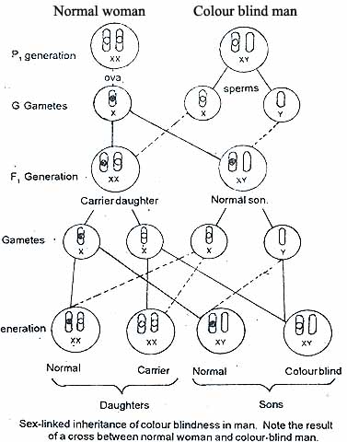
When a normal woman is married to a colorblind man, all her sons and daughters have normal vision. But when her daughters are married with normal colour vision man, some colour-blind sons are formed. It means that a woman with normal colour vision whose father is colourblind gives birth to children of which about half of the sons are colourblind and other half are normal colour vision.

- Cross between colour-blind woman to a normal colour vision men:
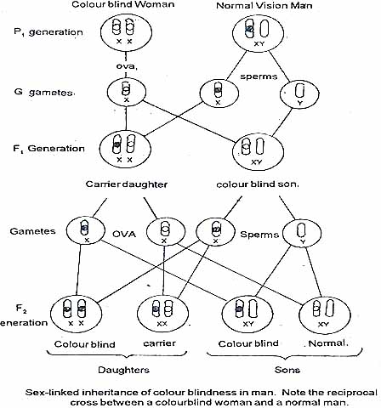
In other instance, if a colour-blind woman married to normal colour vision men, all her sons are colour-blind where as all the daughters have normal colour vision. When these daughters having normal colour vision are married to colour-blind man, the colour-blind grand-sons and colourblind grand-daughters are produced with almost equal number of normal grandsons and grand-daughters It means that a colour-blind woman has sons all colour-blind and all daughters with normal colour vision. A colour-blind woman has always a colour-blind father and her mother is carrier. It is known as criss-cross inheritance. The above results could easily be explained with the assumption that colour vision is sex-linked character and its gene is present on the X-chromosome. Y-chromosome lacks its allele. In man sex-chromosomes are X, Y while in woman these are X & X. It means that a man possesses only one gene for colour vision, whereas woman possesses two. The normal colour vision is dominant over colour-blindness. Therefore, woman will be colour-blind only when she possesses a gene for colour-blindness in both the X-chromosomes, whereas a man will be colour-blind even when this gene is present singly. Always male receives its X-chromosome from mother (through ovum) and V-chromosome from father (through sperm), whereas female receives one K-chromosome from each parent (through ovum and sperm). From the above results following conclusions may be observed.

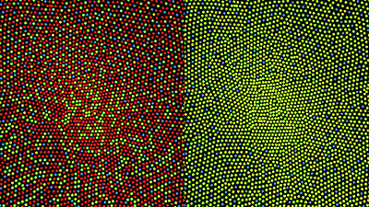

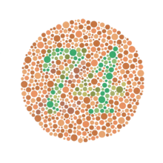
- Colour-blindness is more common in males than in females.
- Two recessive genes are required for the expression of ‘colorblindness in female, whereas only one gene gains expression in male.
- Males are never carriers.
- Colour-blind woman always have colour blind fathers and always produce colour-blind sons.
- Colour-blind women produce colour-blind daughters only when their husbands are colour-blind.
- Woman with normal colour Vision, whose fathers are colorblind, produce colour-blind and, normal sons in approximately equal proportion.
HAEMOPHILIA:
Haemophilia is a group of hereditary genetic disorders that impair the body's ability to control blood clotting or coagulation, which is used to stop bleeding when a blood vessel is broken. Haemophilia A (clotting factor VIII deficiency) is the most common form of the disorder, present in about 1 in 5,000–10,000 male births.^{[2]} Haemophilia B (factor IX deficiency) occurs in around 1 in about 20,000–34,000 male births.
Like most recessive sex-linked, X chromosome disorders, haemophilia is more likely to occur in males than females. This is because females have two X chromosomes while males have only one, so the defective gene is guaranteed to manifest in any male who carries it. Because females have two X chromosomes and haemophilia is rare, the chance of a female having two defective copies of the gene is very remote, so females are almost exclusively asymptomatic carriers of the disorder. Female carriers can inherit the defective gene from either their mother or father, or it may be a new mutation. Although it is not impossible for a female to have haemophilia, it is unusual: a female with haemophilia A or B would have to be the daughter of both a male haemophiliac and a female carrier, while the non-sex-linked haemophilia C due to coagulant factor XI deficiency, which can affect either sex, is more common in Jews of Ashkenazi(east European) descent^{[3]} but rare in other population groups.
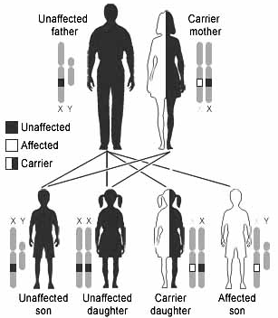
Haemophilia lowers blood plasma clotting factor levels of the coagulation factors needed for a normal clotting process. Thus when a blood vessel is injured, a temporary scab does form, but the missing coagulation factors prevent fibrin formation, which is necessary to maintain the blood clot. A haemophiliac does not bleed more intensely than a person without it, but can bleed for a much longer time. In severe haemophiliacs even a minor injury can result in blood loss lasting days or weeks, or even never healing completely. In areas such as the brain or inside joints, this can be fatal or permanently debilitating.

Royal Disease:
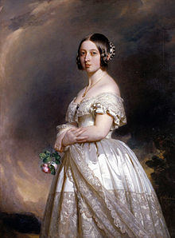
Haemophilia has featured prominently in European royalty and thus is sometimes known as 'the royal disease'. Queen Victoria passed the mutation for Haemophilia B to her son Leopold and, through some of her daughters, to various royals across the continent, including the royal families of Spain, Germany, and Russia. In Russia, Tsarevich Alexei Nikolaevich, son of Nicholas II, was a descendant of Queen Victoria through his mother Empress Alexandra and suffered from haemophilia.
In Spain, Queen Victoria's youngest daughter, Princess Beatrice, had a daughter Victoria Eugenie of Battenberg, who later became Queen of Spain. Two of her sons were haemophiliacs and both died from minor car accidents. Her eldest son, Prince Alfonso of Spain, Prince of Asturias, died at the age of 31 from internal bleeding after his car hit a telephone booth. Her youngest son, Infante Gonzalo, died at age 19 from abdominal bleeding following a minor car accident where he and his sister hit a wall while avoiding a cyclist. Neither appeared injured or sought immediate medical care and Gonzalo died two days later from internal bleeding.

► Haemophilia is also the X-linked recessive disorder.
► In hemophilic persons the process of blood clotting is delayed or blood fails to clot.
► It is known as bleeder’s disease.
► Different forms of hemophilia are
- Severe form or Hemophilia A : It is due to the deficiency of antihemophilic globulin or Factor VIII. It is more common.
- Mild form or Hemophilia B: It is due to lack of Plasma Thromboplastin Component or factor IX. It is less common.
- Hemophilia C: it is due to the deficiency of factor XI. It is autosomal recessive disorder.

Holandric genes:
In mammals, Y-linkage, also known as holandric inheritance, is the determination of a phenotypic trait by an allele (or gene) on the Y chromosome.Because the Y-chromosome is small and does not contain many genes, few traits are Y-linked, and Y-linked diseases are rare. Since the only humans who have a Y chromosome are males, Y-linked traits are passed only from father to son, with no interchromosomal genetic recombination.Y-Chromosome deletions are a frequent genetic cause of male infertility. Having hairy ears was once thought to be a Y-linked trait in humans,^{[1]} but that hypothesis has been discredited.
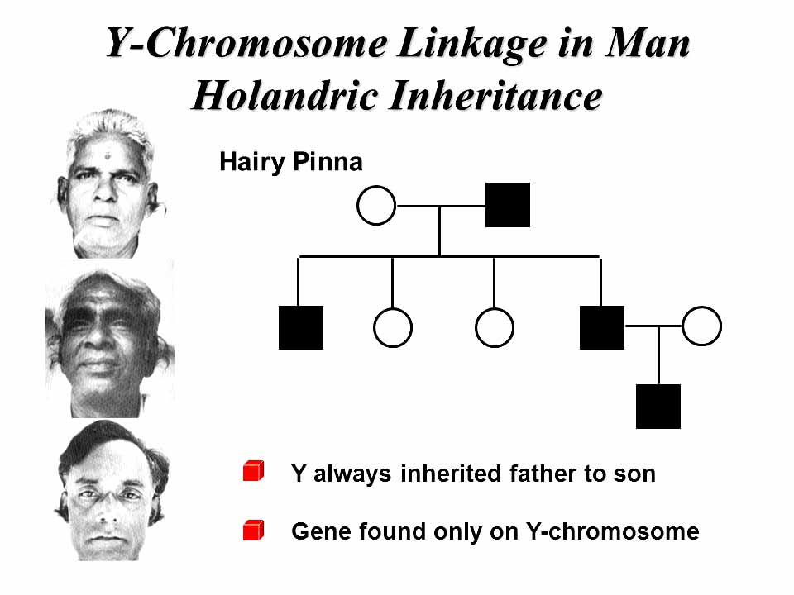

http://www.sakshieducation.com/(S(xuxo5i55fpgtatnghqxqnu45))/home.aspx
xx--oo—xx

