Establishment of Career Guidance Cell in collaboration with Unique academy Pune
(2018-19)
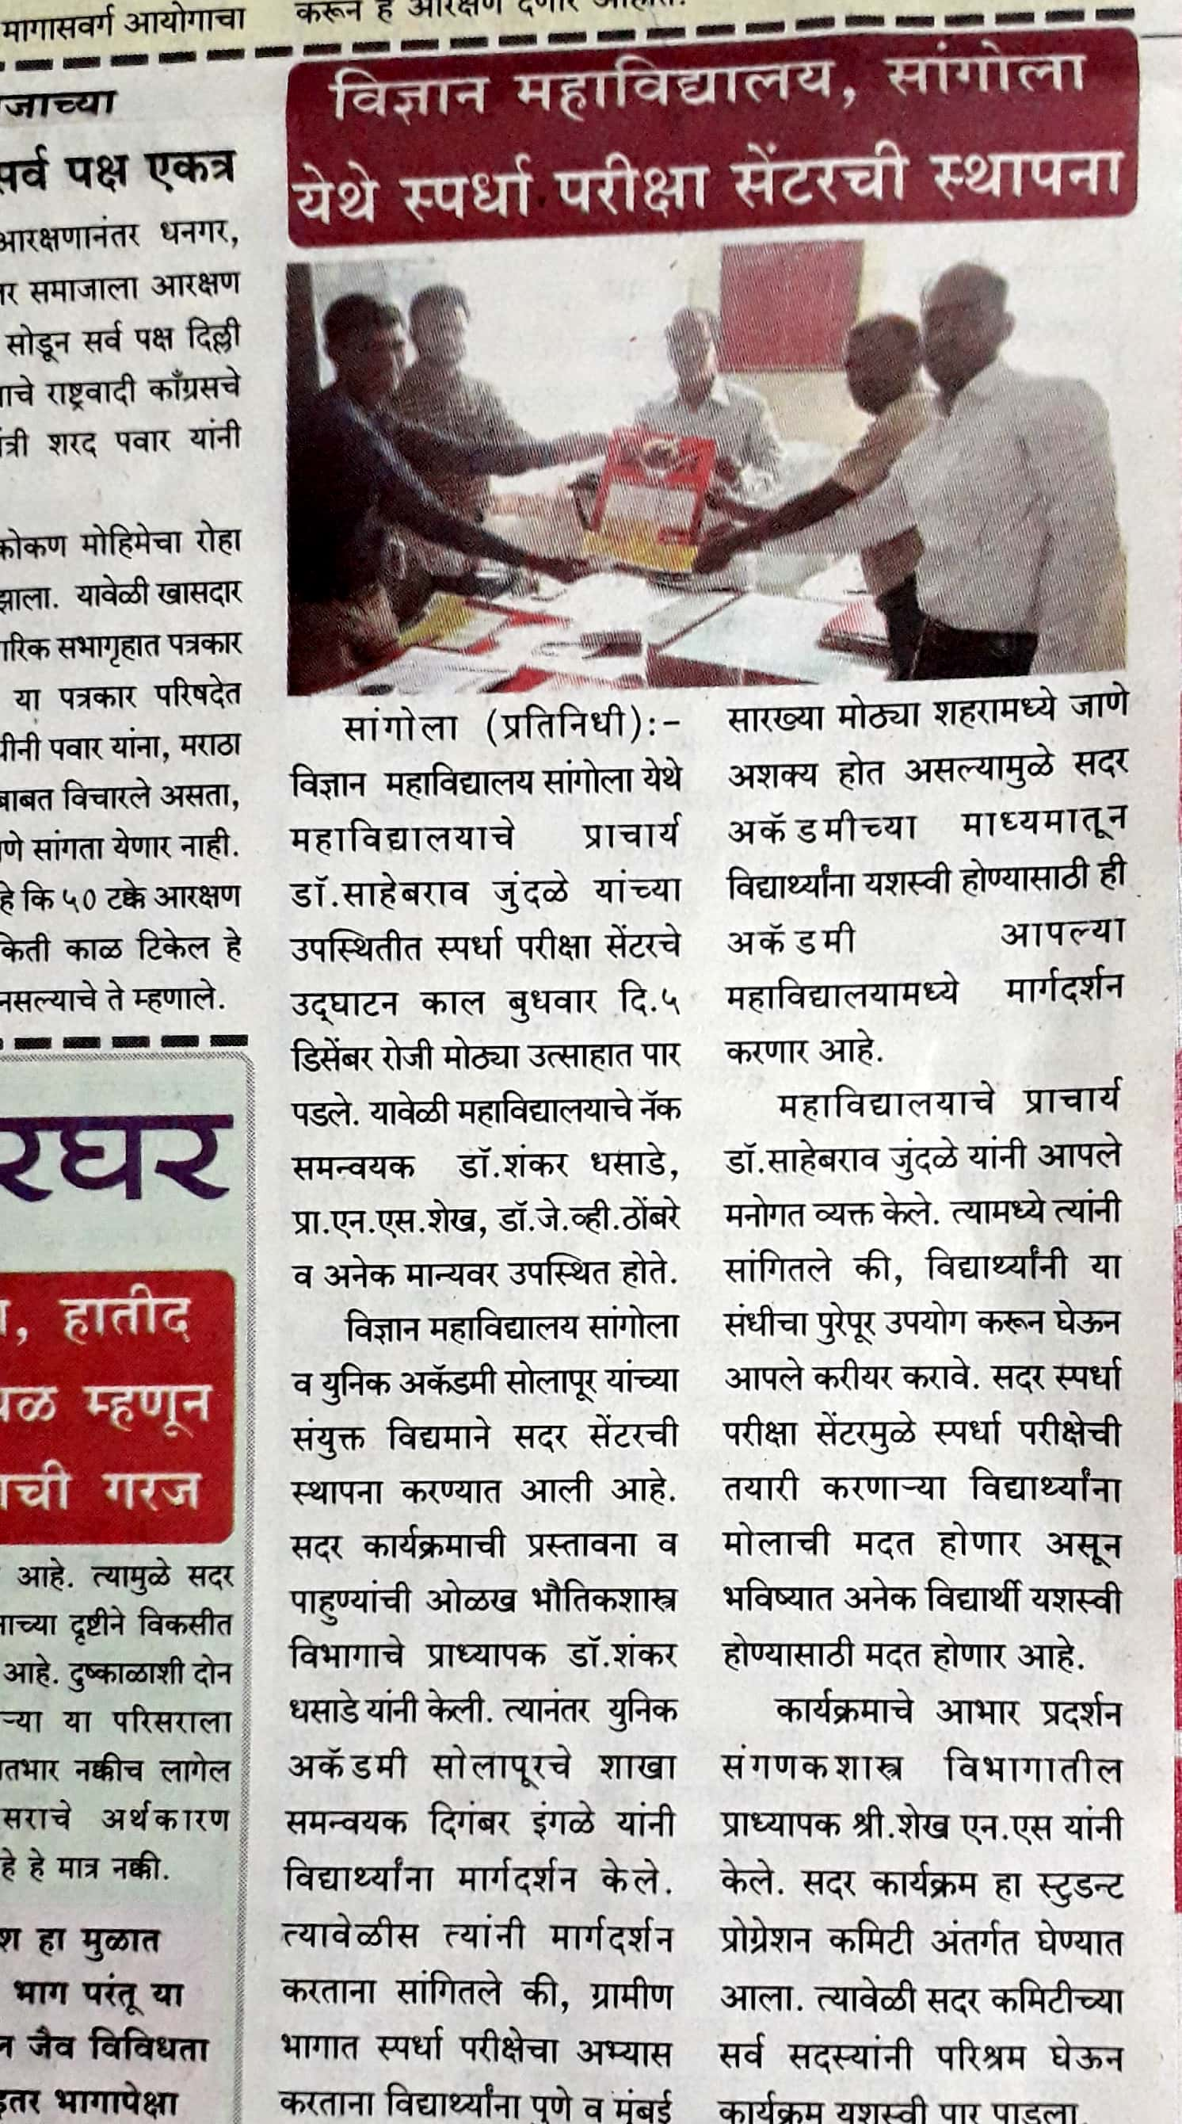
Continued....

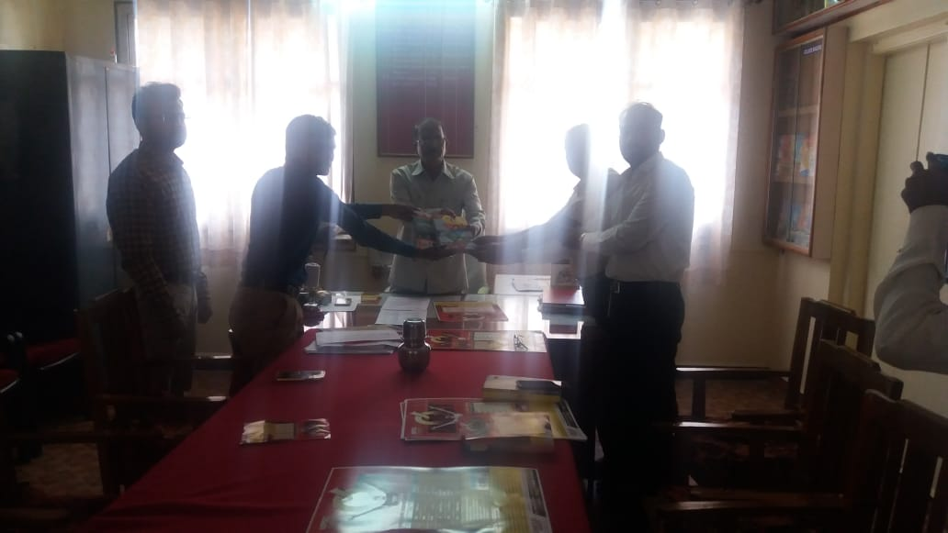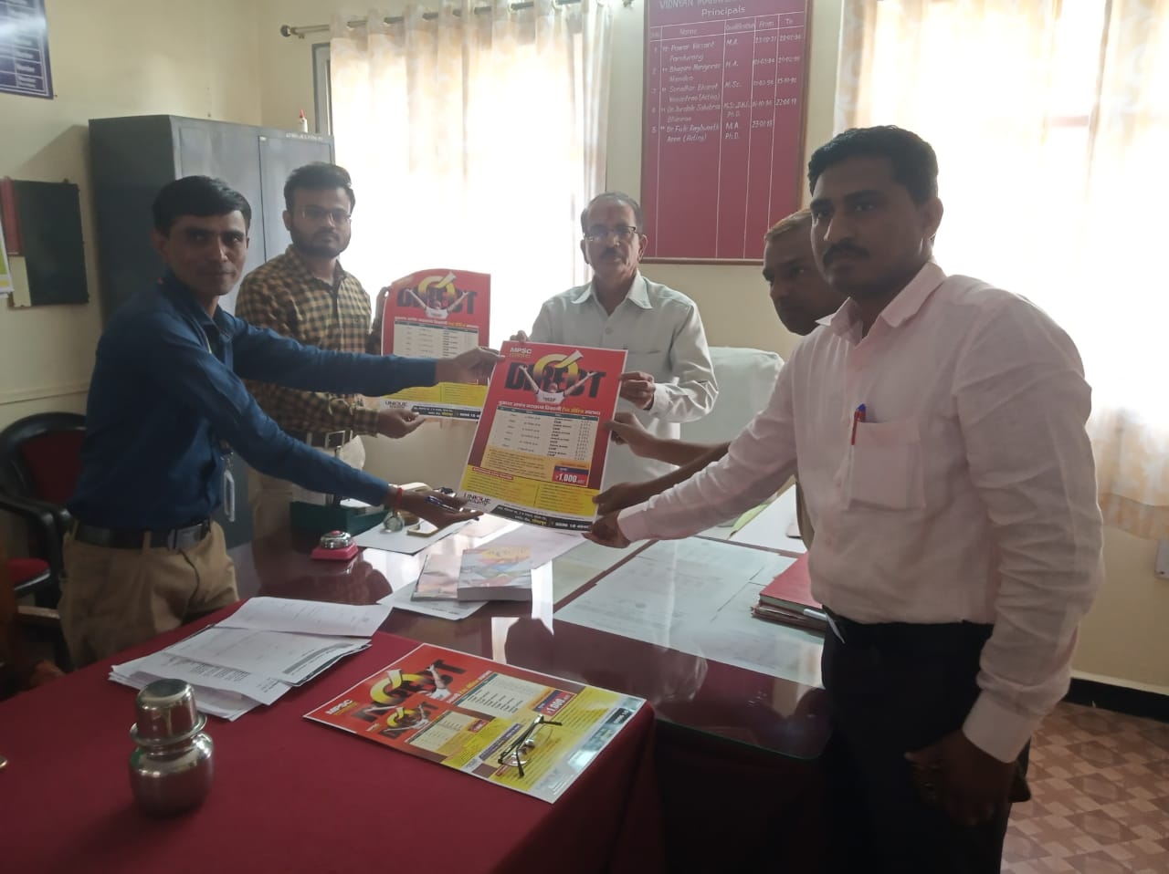

Opening ceremony by Principal Dr. S. B. Jundale and Mr. Ingale Unique academy pune

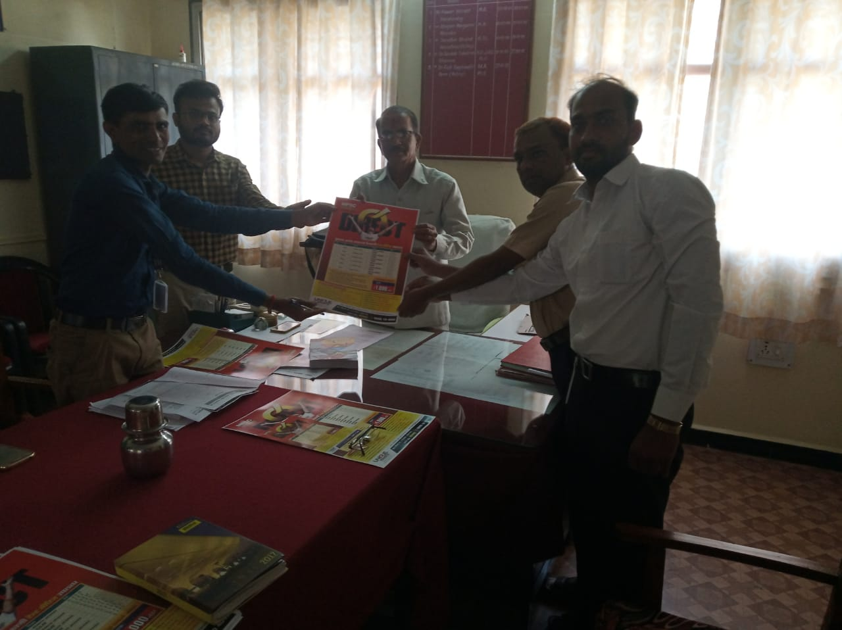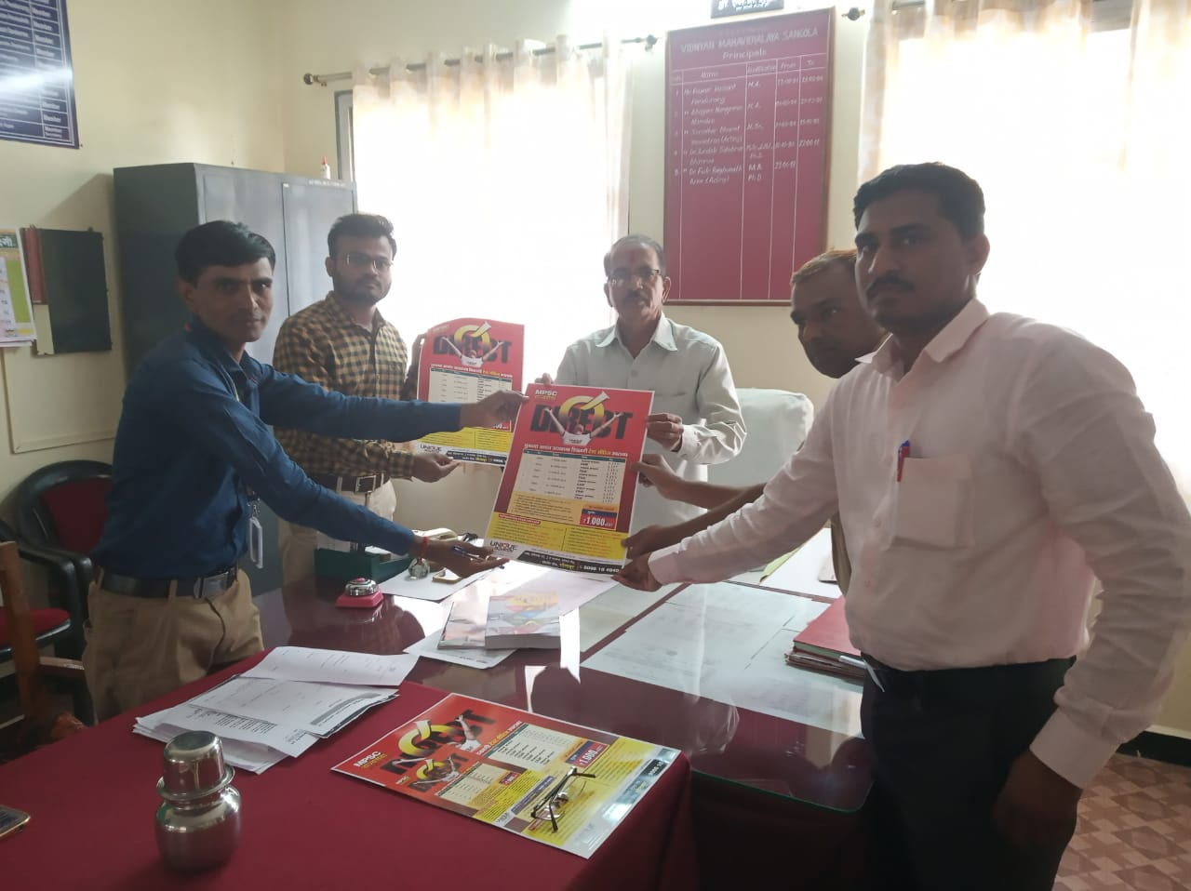

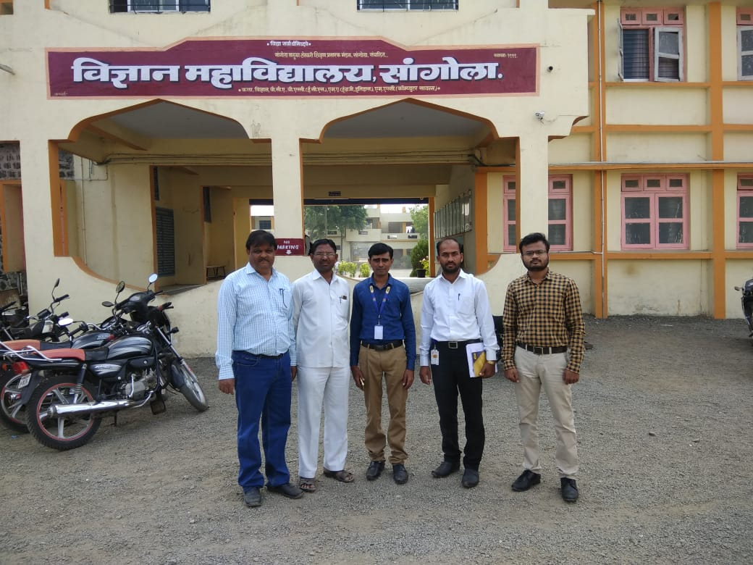

Dr. Fulari, Dr. Mane and Chairman Mr. Shaikh with Mr. Ingale Unique academy pune

